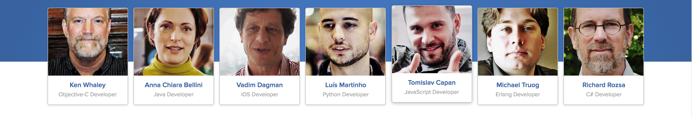

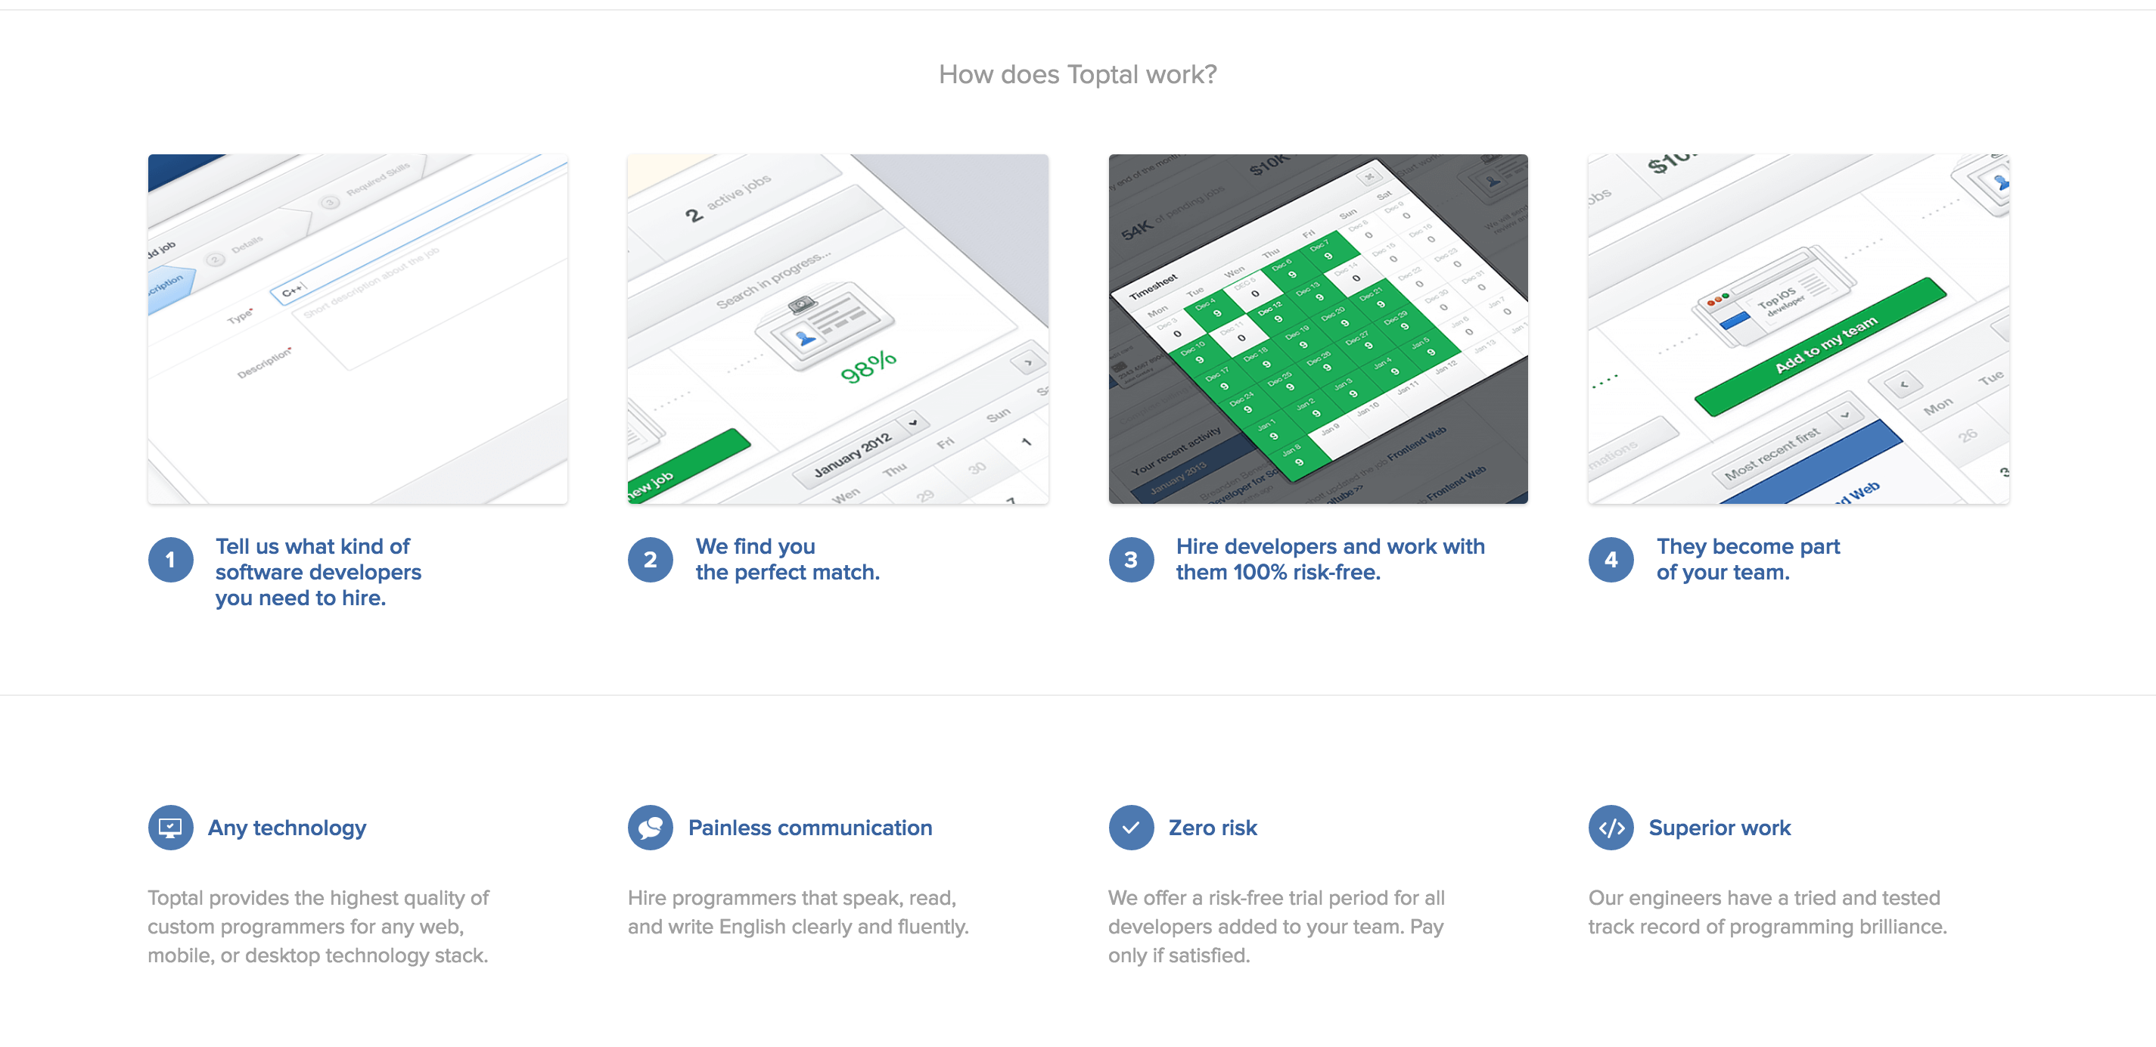

What’s it like to work with Toptal?

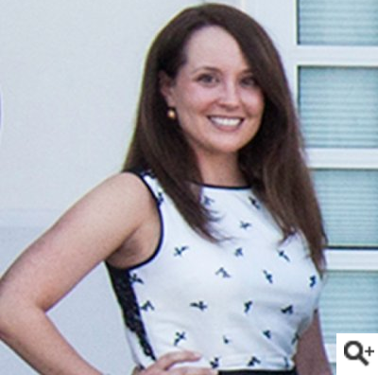

**Lacy Lester, Five Points Management**

**Hired Vladimir Sljubura**

I was nervous to hire externally, but this project was essential and was (so far) going nowhere. Toptal's risk-free trial period was what sold me. We had the design work for our website overhaul completed but couldn't get the various pieces to work together. Two days after I made the decision to get help through Toptal, Vladimir was up to speed on my problem and was already showing me some progress. After four weeks of iterating and checking in over skype, Vladimir delivered a buttoned up website with code that my own developers can now handle. Now the website looks modern and our sales funnel is stronger than ever.

I will definitely work with Vladimir again!



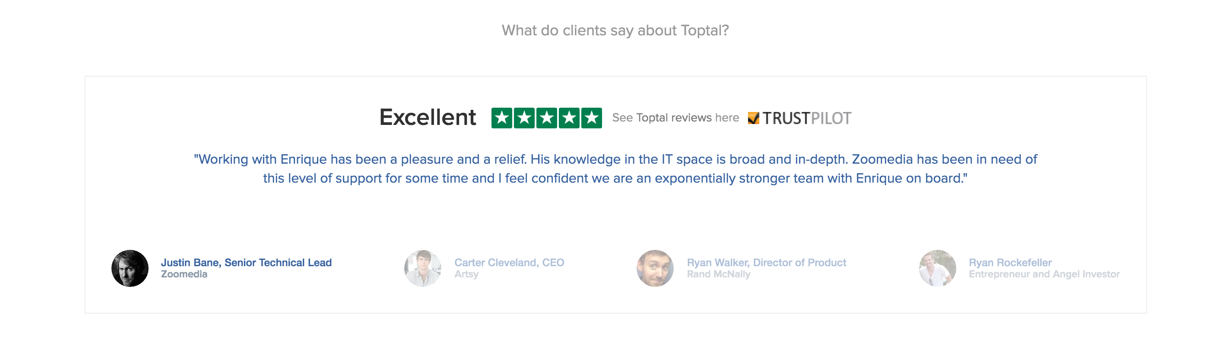

Our developers cover every skillset, with world-class experience.

